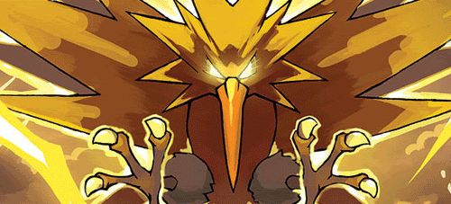**Zapdos!**   **Level 25**

Will not pursue if the average level of the party is below 5. Zapdos gains +15 combat strength for every member of the party, and everyone in the party must join their strength together to try to defeat it. There is no escape, even with the aid of cards like Instant Wall, Magic Lamp, Illusion, etc., or by using any Class/Race powers like the Wizard’s Charm Spell.

**Bad Stuff:** Zapdos is angry! Everyone rolls the die. Zapdos zaps the lowest-rolling half of players (rounding down for odd-numbered parties), and they die. No one may loot their bodies. Everyone else loses 2 levels and the item that gives them the biggest bonus.

**Good Stuff**: Congratulations, you’ve taken down the mighty Zapdos! Everyone gets a level and draws 3 face-up treasures, with an extra level and treasure going to the player who contributed the most combat strength to the party (factor in one-shot item bonuses and monster de-enhancers played on Zapdos).

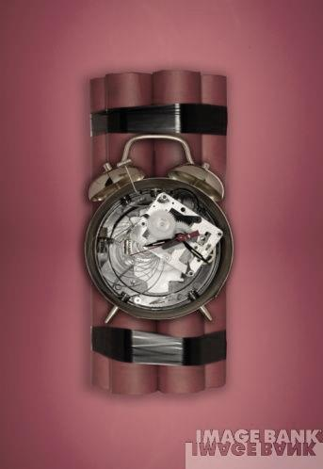**A Clockwork Lemon**

If drawn face-up, the Clockwork Lemon activates immediately, targeting the player who drew it. Otherwise, it may be played at any time on any player. After Charity at the end of the turn of the player targeted by the Clockwork Lemon, they must roll a die. On a 1, the Clockwork Lemon explodes, taking the level of the player down by half (round up for maximum damage), and takes a level off of each of the players adjacent to the victim. Otherwise, the Lemon does not explode, and the player then has the option to sell an item (or items) totaling at least 500 Gold pieces to send the Clockwork Lemon to another player of their choice. The Clockwork Lemon may not be sold, lost to a curse or Bad Stuff, or stolen.

**Yang-Yin** **Level 18**

In order to find inner peace, it is compelled to fight! Will not pursue players of level 3 or less and blocks the use of all Class and Race abilities during this combat. Yang-Yin gains +3 combat strength for each Race or Class card the player has in play.

**Running Away**: All bonuses and penalties to die rolls are reversed when trying to run away.

**Bad Stuff:**

Your gender is changed, with no penalty. All Classes and Races that you had in play whenever Yang-Yin entered combat have their special powers eliminated and reversed for the next two turns!

|  |  |
| --- | --- |
| **Races** | |
| **Elf** | -1 to Run away and may not go up any level(s) for killing monsters that require help from another player. |
| **Orc** | An Orc who is hit with a curse when opening a door suffers as normal but must in addition lose two levels. Anything that cancels the curse will also cancel the level loss. When an Orc fighting alone and defeats a monster by more than 10, he earns no levels. |
| **Gnome** | In combat alone, any *one* player may play one monster from their hand as a one shot bonus to the monster you are currently fighting. You get -1 for any non-one shot item beginning with the letters G or N. |
| **Dwarf** | You can carry no Big items and your hand limit is reduced to 4 cards. |
| **Halfling** | All items you sell are at half price. If you succeed your initial run away roll, any one player may discard a card to make you try once more. |
| **Human** | You may go through the discard pile to pick up and play any race card(s) that you can immediately use.  “You’re not real”- You can choose to disbelieve in any monster you encounter for no treasure and no levels. |
| **Classes** | |
| **Wizard** | Fight Spell- Collectively up 3 cards may be discarded after rolling the die to run away; each gives you a -1 bonus to flee.  Taunt Spell- Any one player may discard their whole hand (minimum 3 cards) to entice a single monster into the battle. |
| **Thief** | Incompetence- Other players may discard a card to cause you to grab the wrong end of your dagger.  (-2 in combat) Each player can only do this once per combat.  Charity- Any player may discard a card to receive your “donation” of a small item of their choosing. The receiving player rolls a die; 4 or more succeeds. Otherwise the player must return the item and lose a level. |
| **Cleric** | Necromancy- Collectively up 3 cards may be discarded when you are in combat against an Undead creature. Each discard gives the Undead creature a +3 bonus.  (Divine Wrath- causes Clerics to lose a level) |
| **Bard** | Reverse Enthrall- Any player in combat may discard a card to try to enthrall you. Each of you rolls a die; if his roll beats yours, you must help and cannot ask for a reward. Players cannot win the game by exploiting this power.  Bardic Misfortune- When you win a combat on your turn, draw one fewer treasure. |
| **Warrior** | Pacifistic Thoughts- Collectively up 3 cards may be discarded when you are in combat; each discard gives you a -1 bonus.  (Warriors must win combats by 2) |
| **Classless** | You may go through the discard pile to pick up and play any class card(s) that you can immediately use. When any player wins a combat, you may draw a face down door card. |

**Good Stuff:** 4 Treasures and 2 levels